**Tarun Singh 2110110552 ts424@snu.edu.in**

*Worksheet 1*

*Question-1*

1. man /proc/cpuinfo

Processor- A processor is the logic circuitry that responds to and processes the basic instructions that drive a computer.

Cores- A processor core is a processing unit that reads instructions to perform specific actions

1. cat /proc/cpuinfo/grep cores

Answer – **6 cores**

1. cat /proc/cpuinfo/grep processor

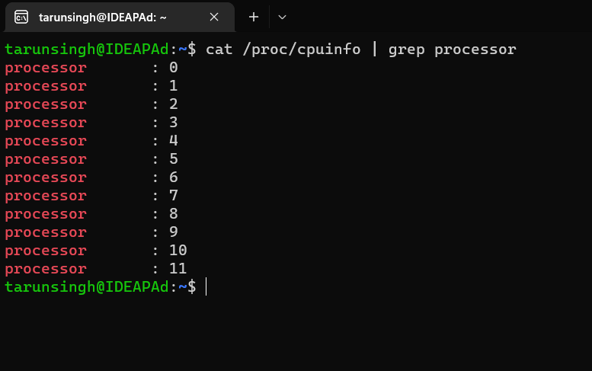

Answer – **12 processors**

1. more /proc/cpuinfo

Answer – **2096.001 MHz**

1. arch

Answer – **x86_64**

1. cat /proc/meminfo | grep MemTotal

Answer – **2920120 kB**

1. cat /proc/meminfo | grep Free

Answer – **2755340 kB**

1. vmstat -f **267 forks**

vmstat -s **34571 context switches**

*Question-2*

1. PID=5967
2. CPU being used = 100%

Memory being used = 0.0%

1. Running (R)

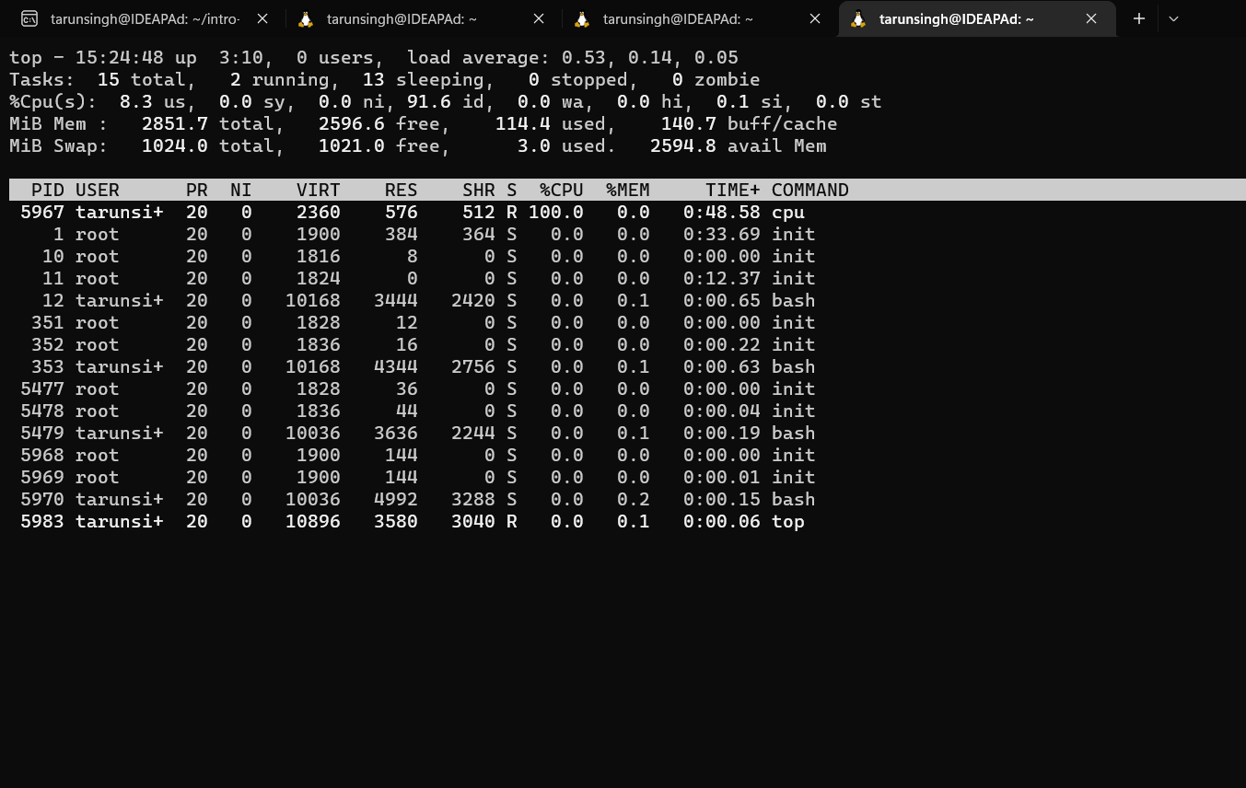

*Question-3*

1. ps -C cpu-print -o pid

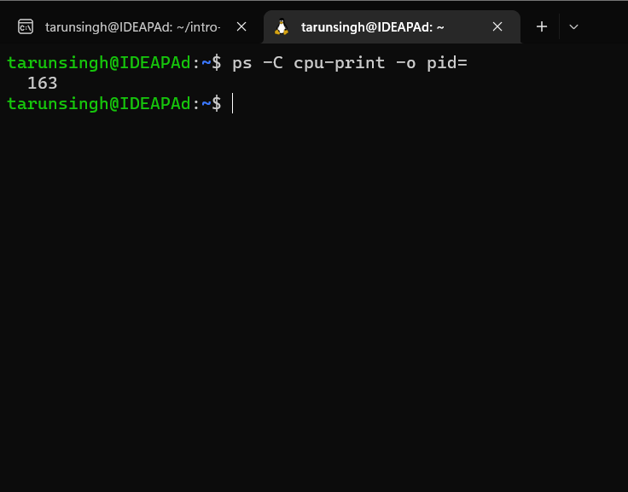

Answer - **163**

1. ps -C cpu-print -o ppid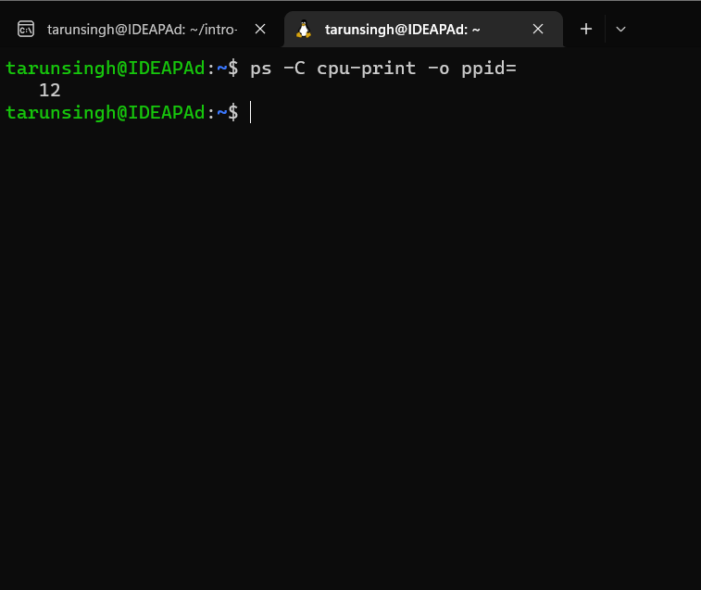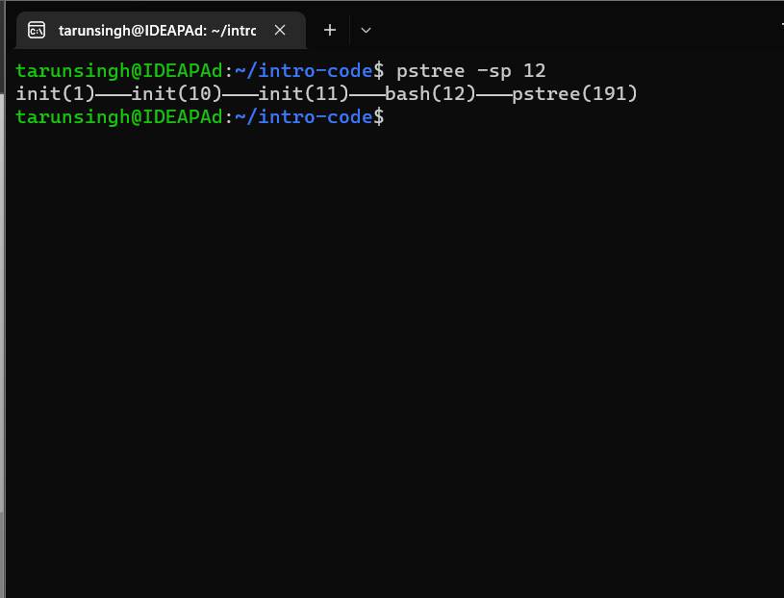

Answer – **12(Parent PID)**

1. **./cpu-print > /tmp/tmp.txt &**

Gives output 652

1. **./cpu-print | grep hello &**

Gives output 655

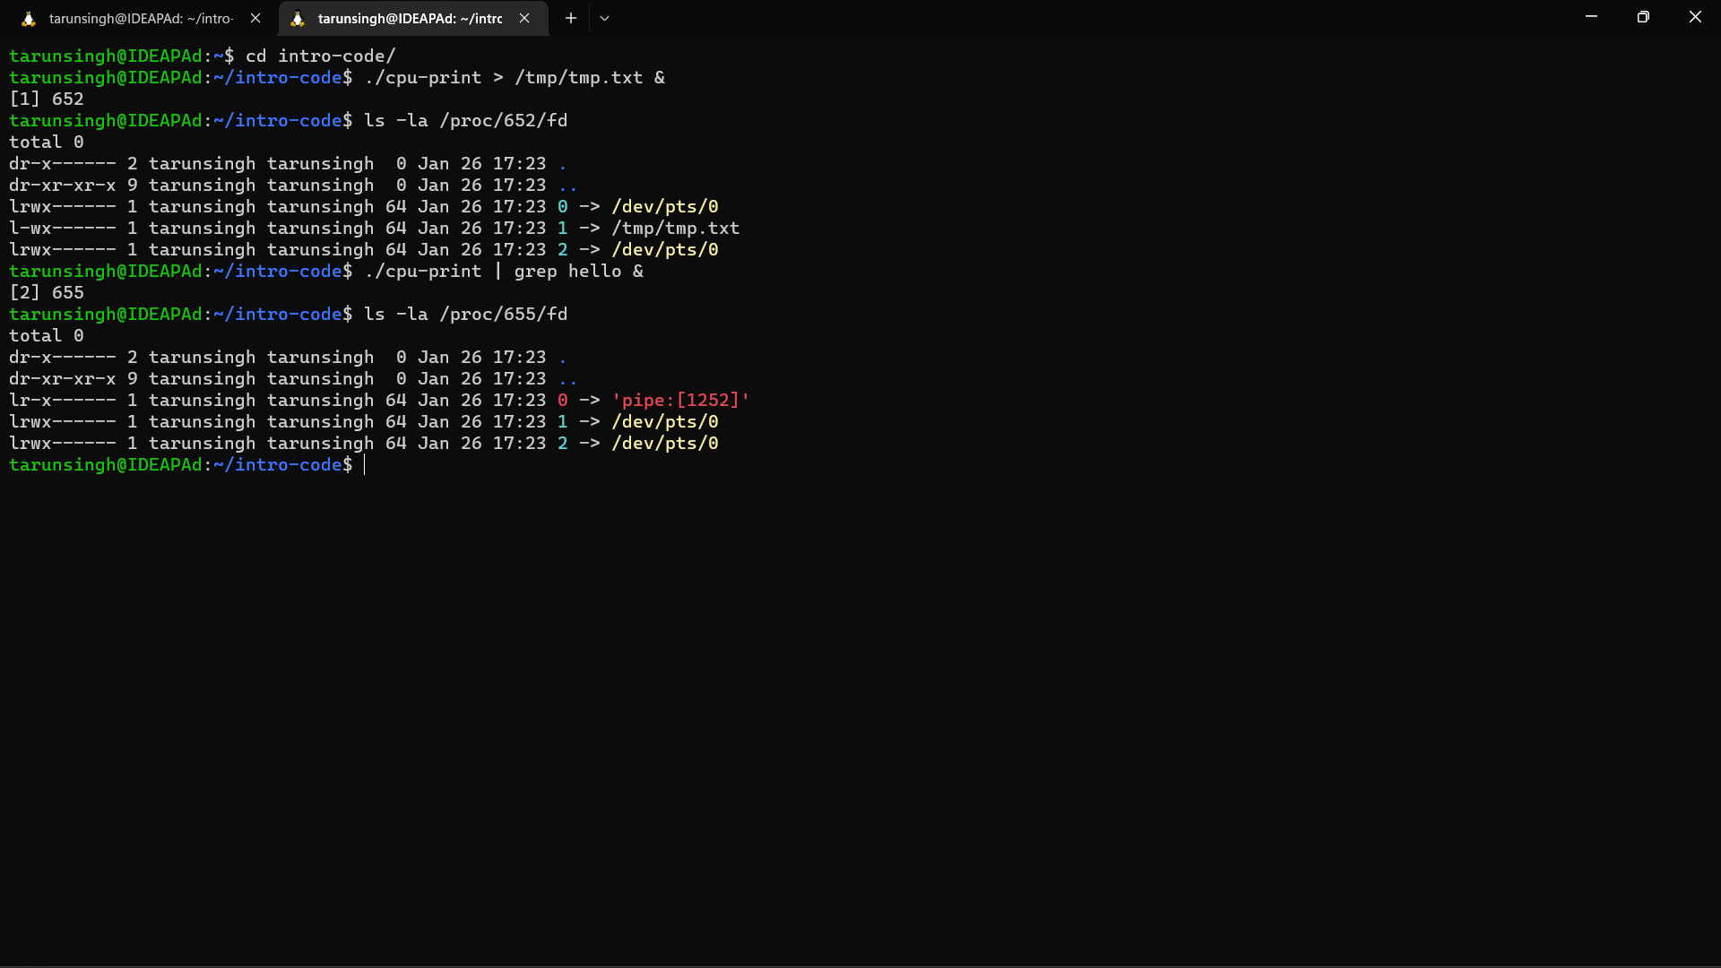

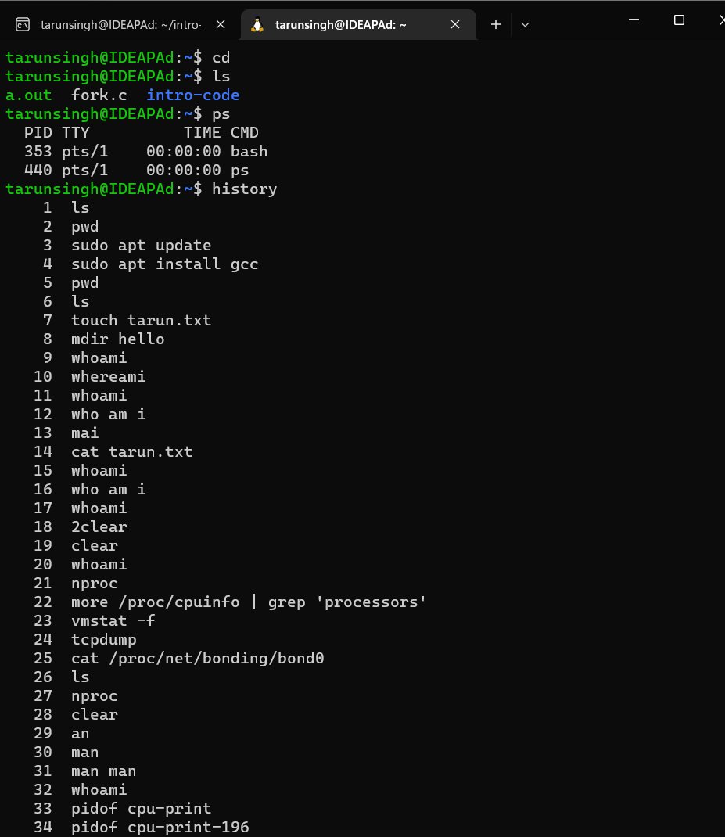

**cd** command does not give any outputs.

**ls,history,ps** do give their respective outputs.

*Question – 4*

VSZ- Virtual Memory

RSS- Real Memory

**Memory1.c**

Virtual Memory- 6276

Real Memory- 4948

**Memory2.c**

Virtual Memory- 6276

Real Memory- 5000

**Observation**- As we see that the real memory being used in second process (memory2.c) is comparatively more than the first process (memory1.c).

*Question – 5*

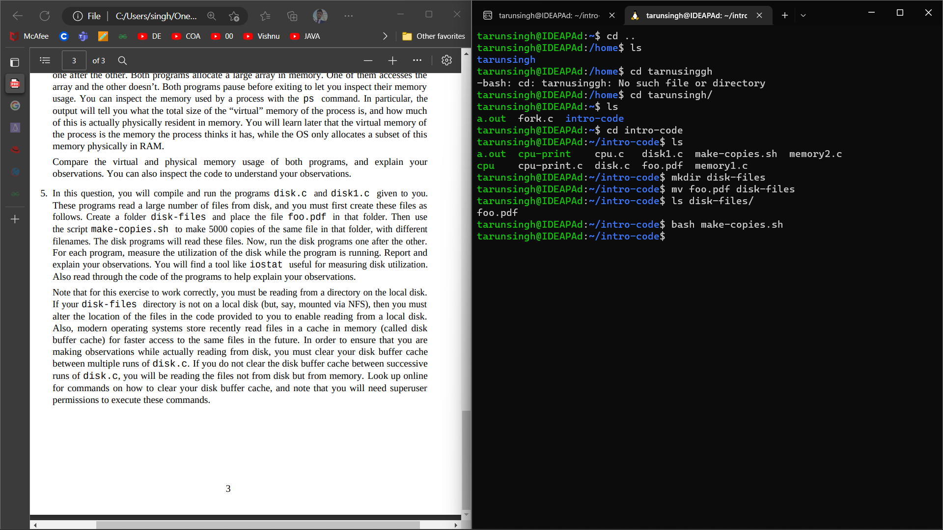

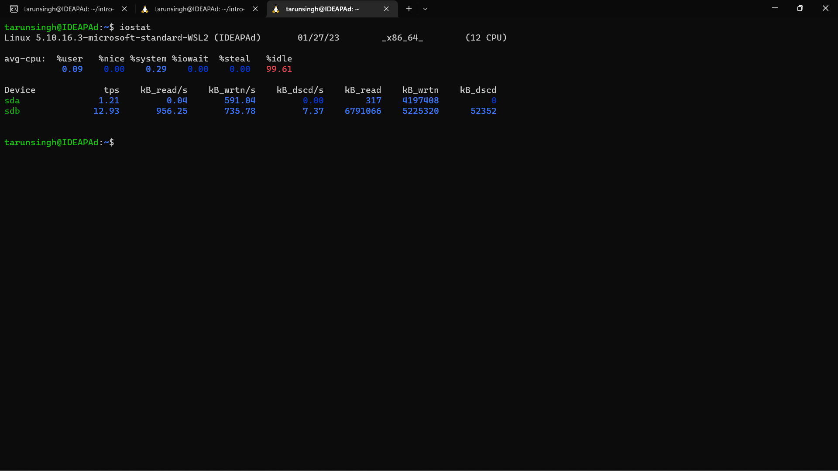

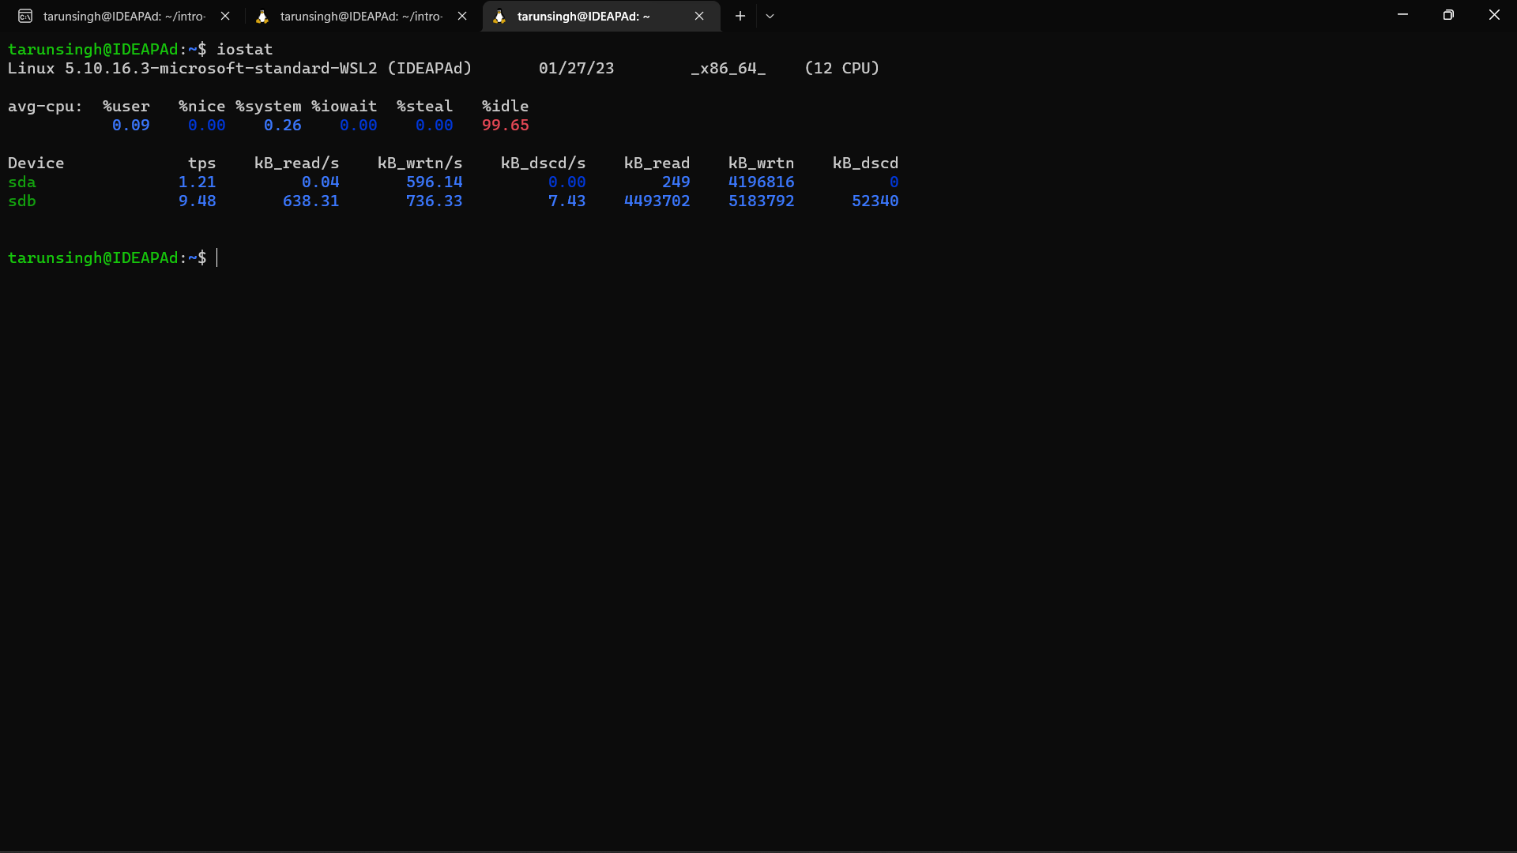

To clear disk buffer cache = **free -m**